Project Design Phase

Solution Architecture
Date | 14 July 2026
Team ID | __________
Project Name | Shopezz – MERN E-Commerce Platform
Maximum Marks | 4 Marks

Solution Architecture
Shopezz follows a three-tier MERN architecture. Users interact with a React.js frontend that communicates with secure REST APIs developed using Express.js. Node.js processes authentication, product, cart, order and admin operations, while MongoDB Atlas stores application data. JWT-based authentication and bcrypt password hashing provide security. The modular design improves scalability, maintainability, and performance.
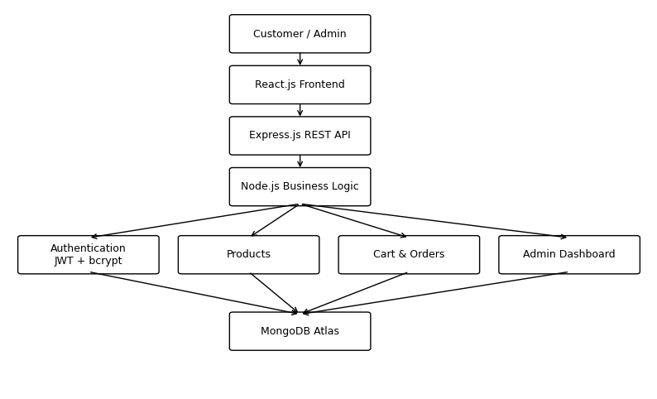

Architecture Components
- Presentation Layer: React.js responsive customer and admin interfaces.
- API Layer: Express.js REST APIs for products, users, orders, cart and authentication.
- Business Layer: Node.js controllers implementing application logic.
- Database Layer: MongoDB Atlas for users, products, orders and cart data.
- Security: JWT authentication, bcrypt hashing, route protection and role-based access.
- Deployment: React on Vercel, Node/Express on Render, MongoDB Atlas cloud database.
- Future Enhancements: Razorpay payments, Cloudinary image storage, AI recommendations and analytics.

